TITLE OF THE PAPER

I. POPESCU A. JONES

Abstract: These instructions are formulated for presenting the template used for editing the articles for the scientific journal Bulletin of Transilvania University of Braşov. The material presents the camera ready form of the articles. The abstract should synthetically outline all the pertinent results, in a short but intelligible form. The abstract should begin through clearly stating the purpose of the paper and should end by formulating the most important conclusions. There will be used short, direct and complete sentences, written in a single paragraph, without “tab”-s. The abstract will have 7...10 lines.

Key words: 3…5 significant key words.

1. Introduction

The format of the bulletin will be A4. The article, inclusively the tables and the figures, should be of 6-8 pages, an even number of pages being compulsorily. The last page will be filled at least 70%.
A person may participate, within a volume, with one paper as first author or as co-author. The paper will be written in British English, using (Calibri, Microsoft Word). We strongly advise to use this template and insert the text of the paper directly within this file.

2. Instructions for Editing

The papers will be handed on quality printing machine paper, of colour flat white, in the standard form described herein and also in electronic format, identical with the printed copies.

2.1. Format of the Papers

There will be used the format A4 (210 mm x 297 mm), the limits of the printing zone being set using „Page setup”: margins: upwards - 5 cm, downwards, left, right - 3.5 cm; heading - 4 cm; foot margin - 0 cm; „Different” first page; „Different” pages even and uneven.
The paper will be drawn up in two columns, of the width 67.5 mm, separated through a space of 5 mm. Exceptions are the title of the paper, the authors and their affiliation, the abstract and the key words, which will be drawn along the page.

3. Arranging the Text within the Page

Title of the paper - Calibri 18 pt. capital letters, bold, centred along the page, indenting left 1 cm, single spacing.
Under the title, there is left a free line (18 pt.).

Author(s) - Calibri 14 pt., bold, centred along the page, indenting left 1 cm, (single spacing:
- first name „title case” and name in capital letters, when there is a single author (ex. Ion POPESCU);
- initial of every author’s first name and the name, in capital letters; they will be not separated through coma and may be written on 2 lines unless they fit within a single one.
Between the authors and the abstract, there will be left a free line (14 pt.).

Authors’ affiliation - CALIBRI 9 pt., regular, justified left-right along the page, on one line.
The full affiliation (groups, laboratories and the institutions) of the authors will be specified as references in the footnote (Insert Reference, Footnote, Bottom of page); these ones will be marked with Arabic numerals. If several authors are part of the same organization, then its name may be written once and the authors will be marked with the same figure.

Abstract - Calibri 12 pt., italic, bold; body text of the abstract of the paper: CALIBRI 10 pt., italic, regular, justified left-right (justify) along the page, single spacing.
The abstract of the paper will consist of 7...10 lines, with justification left 2 cm, right 1 cm.
Between the abstract and the key words, there will be left a free line (10 pt.).

Key words - Calibri 12 pt., italic, bold. There will be written 3…5 significant key words (or groups of words): CALIBRI 10 pt., italic, regular, justified left-right (justify) along the page, single spacing, justification left 2 cm, right 1 cm.
Between the key words and the text of the article, there will be left two free lines (2 ×10 pt.).

Text chapter - Calibri 11 pt., bold, “Title case”, justified left, indenting 0, single spacing, hanging 0.4 cm.
The titles of the sections are successively numbered in Arabic numerals, followed by full stop and a space.
Sections Acknowledgements and Bibliographical References will not be numbered.
Above and beneath Text chapter, there will be left a free line (11 pt.). If the titles of several sections are to be found on the first line of a column, then they will not be preceded by free spaces.

Text subchapter - Calibri 11 pt., bold, “Sentence case” justified left, indenting 0, single spacing, hanging 0.7 cm.
The number of the subchapter includes the number of the main chapter, full stop, the number of the subchapter, full stop and a space.

Main text - Calibri 11 pt, regular, justified left-right, single spacing. The first line of every paragraph will be indented at 0.3 cm.

3.1. Other Data With Reference To Drawing up the Content of the Paper

There is recommended to divide the paper in the following chapters: Introduction, Objectives, Material and Methods, Results and Discussions, Conclusions, Acknowledgements, References.
At the beginning of every page, except the first, above one demarcation line, there will be written the heading with 10 pt., straight, with a demarcation line of 0.1 mm and of the length of 140 mm. Between the demarcation line and the text, the distance is the normal one between two lines (11 pt.).
On the even pages, there will be written the title and the number of the bulletin, CALIBRI 10 pt., justified to the left, and on the uneven pages there will be written the title of the paper (on a single line), CALIBRI 10 pt., “Title case”, justified to the right. The current number of the page will be written, with 10 pt., on the margin which has not been filled in yet. In the final editing process, the page number will be changed by the editor.

• Tables and Figures

The figures (drawings, diagrams, images) and the tables will be included, in order, within the text, centred. Those of small dimensions will be inserted within the paragraphs, their width not exceeding the width of the column they are part of; those of larger dimensions may be introduced on the entire width, preferably at the beginning or in the end of the page.
The figures (of high quality) will be placed as closely as possible to the place they are first being mentioned in (there is recommended to avoid the placement of the figures before their first mentioning within the text).
The text with the explanation of the figure, placed under the figure (Calibri 11, italic, centred, spacing 6 pt. before, on one line), will be preceded by „Fig.” followed by a space, the number of the figure (Arabic numerals), full stop and space (Calibri 11 pt., regular) as in the examples for Figures 1 and 2.
Within the text, the references to the figure (table) will be made by writing Figure x (Table x), inclusively within the sentence. The texts within the figures (in English) will be of a size that should ensure a good readability.

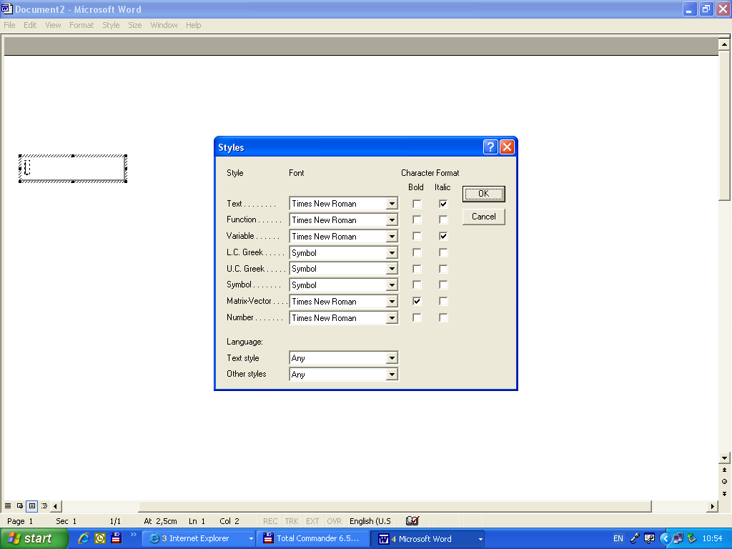
Fig. 1. Drawing inserted within the text

There will not be accepted papers that contain blurred figures or that have not all the elements grouped. Therefore we kindly ask you to use the command Group (in the Drawing toolbar).
Tables (numbered in Arabic numerals) will be placed in the text as close as possible to the first reference to them. The size of the font used for tables is Calibri 10 pt., regular, on one line (Table 1). For bigger tables, there may be also written with Calibri 9 pt.
All the tables have to be created using the utility Table. The measuring units will be put down within square brackets, in the head of the table.

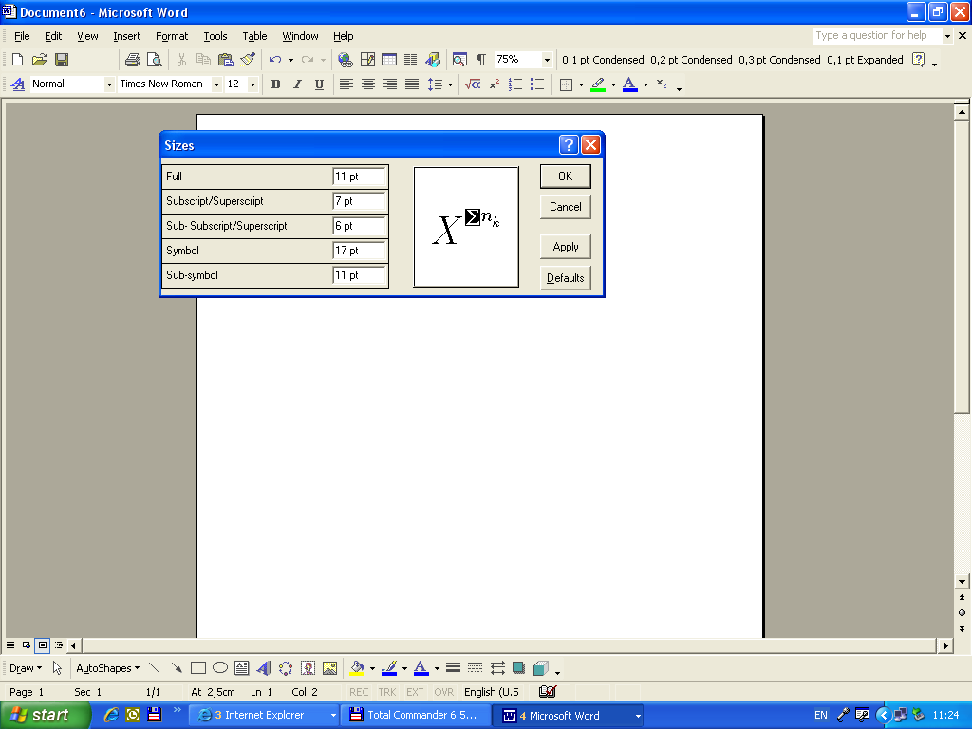
Fig. 2. Image of ......

Denomination of the table Table 1
Efficiency [%] | 94.37 | 96.58 | 93.18 | 83.66 | 75.30
… | … | … | … | … | …
… | … | … | … | … | …
… | … | … | … | … | …

Tables captions will be placed above the table (Calibri 11, italic, centred, spacing 6 pt. afterwards, on a single line, followed by „Table x” (Calibri 11, regular, justified to the right).
There is preferable to use tables no longer than the useful length of a page. In exceptional cases, there may be also used tables placed on a page type landscape.
Unless the tables and the figures are original, at the end of the title, the references must be quoted.

• Symbols and acronyms

There is recommended the use of standard symbols and ISO abbreviations. The international system of units (SI) is compulsory. The use of the British units may be done only as secondary units (in brackets). There will be avoided the combination of the SI and CGS units. Define every acronym during its first apparition in the text. For the documents with several acronyms, there is recommended to display them in a list in the end of the article.

Acknowledgements
This short section will be written right before Bibliography and will have the format as the title of the chapter without being allotted a number. The acknowledgements may be addressed to the persons or to the institutions that are not being mentioned elsewhere in the text and that played an important role in obtaining the results submitted within the paper.

• Quotations and references

The bibliography will be written after the last chapter, on two columns. The word Bibliography will be formatted as the title of the chapter and will not be numbered.
Every title will have a number, followed by full stop (there will not be used the parentheses) and will contain the author’s (authors’) name and initials(s) of the first name, separated through coma, the title of the reference in original and the one translated in English (between parentheses), in italic, followed by the locality, the publishing house and the year of issuing (for the monographies) or by the title of the magazine, the number of the volume, the number of the magazine and the pages of the article (for the periodicals). In order to mention the works published in Slavonic languages, there will be used the system of transliteration in the Latin alphabet.
The references will be organized in alphabetical order, considering the name of the first author, and in chronological order for the publications of the same author.
All references have to be quoted in the text. Within the text of the paper, the bibliographical references will be made through mentioning the current number in the bibliographical list, framed within square brackets [1], [2], [3]… If there are more than two references, continuously numbered, the numbers have to be separated through a line (hyphen) [1-6].
Models for arranging the bibliographical references:
- books: (Surname1, N1., Surname2, N2.: Name of the book in original (translation in English), in Italics, Title Case. Place of Publication. Publisher, Year. p. (first-last). See: [2], [4], [5];
- articles in periodicals: (Surname1, N1., Surname2, N2.: Name of paper. In: Name of Journal x (year) No. w, p. (first-last). See: [8], [10];
- articles in conferences: (Surname1, N1.: Title of conference paper. In: Proceedings of Conference Name, Editor Name (Ed.), Conference location, Publisher, City, Country, month and year, p. (first-last). See: [11].
- articles or chapters in books: (Surname1, N.N1, Surname2, N2.: Name of paper. In: Name of Book, Name(s) of Editor(s), (Ed.). Publisher, Place of publication, Year, p. (first-last). See: [1].
In case there are several authors, there will be written the first 2 authors followed afterwards by et al. For the periodicals, the entire name or the usual international abbreviations will be used.
Authors are encouraged to quote papers published in the previous editions of BUT.

• Other specifications

The entire responsibility for the content of the paper pertains to the author. The author has to obtain the right to make use of any material undergoing copyright protection.
The affirmations and the opinions submitted in the published articles are understood as individual expressions pertaining to the author and not to the editors of the journal.
The per-reviewing of the articles and the supervision of the English translation will be assumed by the members of the Editing Committee, together with the editing secretaries. The supervision of the translation is only accomplished by the professorial staff of the Faculty of Letters, named upon the faculties.

Other information may be obtained from the address: rector@unitbv.ro.

References

- Arustei, O., Schender, C.: Handbal. Conținut, Mijloace (Handball. Content,
Means). Iași, Editura Demiurg, 2008, p. 15-17.
- Crețu, M., Mihăilă I.: Acrobatic Training of Junior Athletes in Gymnastics. In: Procedia - Social and Behavioral Sciences, Vol. 46, 2012, p. 4165-4168, DOI:10.1016.
- Dobrescu, T., Grosu, E.C., Culea, C., et al.: Considerations regarding the creative dimension of the physical education and sports didactic process, according to the students' opinions. In: The 3rd World Conference Learning, Teaching & Educational Leadership, WCLTA, octomber, 2012, Brussels, Belgium, p. 300-310.
- Ploieșteanu, C.: Optimization procedure for selection to soccer. In: The Annals of Dunărea de Jos University of Galați, Fascicle XV, Vol.1, 2010, p. 106-108.
- Segărceanu, A.: Selecţia sportivă în tenisul de câmp în sistemul pregătirii multianuale (Sports tennis selection in the multi-annual training system). In: Ph.D. Thesis, State University of Physical Education, Chişinău, 2007, p. 10-28.
- Wigdén, I.: To Install Automation
- http://but.unitbv.ro/BU2008/index.htm. Accessed: 06-01-2009.
- *** Homogeneous Charge Compression Ignition. Available at: http://en.wikipedia. org/wiki/HCCI. Accessed: 22-06-2008.
- *** SR EN 1050-96: Regarding the Evaluation of Professional Risks. Available at: 26.12.1996.
Observation: If a DOI has been assigned to the journal articles that are cited, author(s) should include this after the page number for the article

Departament of Motric Performance”, Transilvania University of Braşov.
Organization of appurtenance for the second author.

